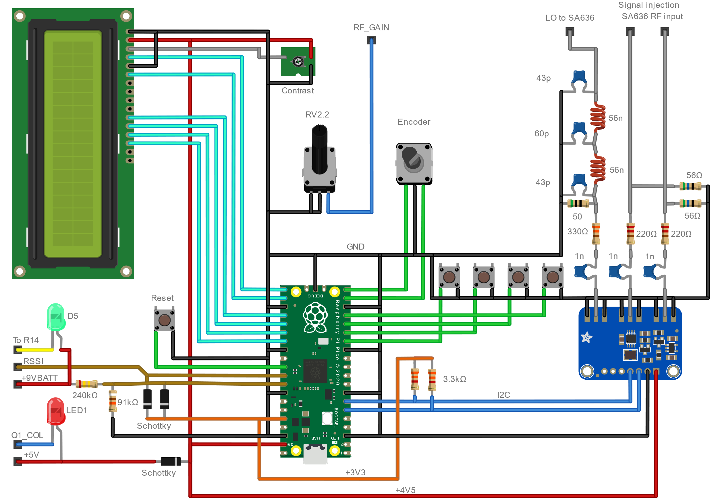

”Breadboard” connections for the Pi Pico, LCD, Si5351 board etc.



Modified ROX-2X circuit diagram.